Lab Assignment - 3

**MODULATION USING SIMULINK**

|  |
| --- |
| Course Outcome:  CO2: Realise various communication systems using software defined radio systems. |

**Simulink**

Simulink is a program for simulating signals and dynamic systems. Simulink has two phases of use: model definition and model analysis. A typical session starts by either defining a new model or by recalling a previously defined model, and then proceeds to analyze that model. In order to facilitate the model definition, Simulink has a large library of blocks. Models are created by combining proper blocks from the library and edited in the model window principally using mouse driven operations. An important part of mastering Simulink is to become familiar with manipulations of various model components in these windows.

After you create (or define) a model, you can analyze it either by choosing options from the Simulink menus in the model window or by entering commands in the Matlab command window. The progress of an ongoing simulation can be viewed while it is running, and the final results can be made available in the Matlab workspace when the simulation is complete.

Modulation is defined as the process of changing the characteristics (Amplitude, Frequency or Phase) of the carrier signal (high frequency signal) in accordance with the intensity of the message signal (modulating signal).

**To Start Simulink**: Start Matlab then type simulink on the command line. A Simulink Library Window opens up as shown in figure. In the lower left part, all the blocks directories are listed, some directories may have subdirectories. If you choose any directory or subdirectory, all the subdirectories or blocks can be seen in the right part of the library window.

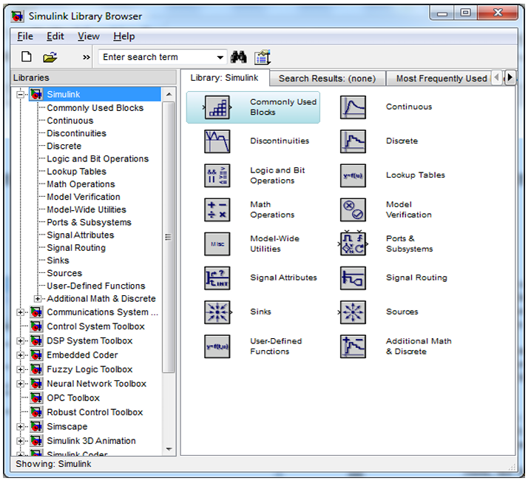

**Example:** Design a model to analyze the signal m(t)= cos(2π*200t) in time and frequency domain.

Steps

1. In the library browser, click on the directory Simulink\Sources. All the signal generator blocks will be listed.
2. Choose a block (Sine Wave), and click the right button of the mouse. Select “Add to new model”. The sine wave generator source block will be added in the model window. OR

Double click on the model window and type sine wave. Then the block will be added to the model window.

1. In your model window, double-click on the sine wave generator block and you can adjust the block (signal or system) parameters. Here in this example, specify the model fields as follows: Frequency: 2*pi, Phase shift: pi/2, Sample time: 1/4000 (it should be less than half of the message signal period at least) Then, the Sine Wave block will produce a signal sin(2π*200t+π/2)=cos(2π*200t).
2. To check the output of the signal generator in time domain, you can add a ***TimeScope*** block from the directory Simulink\ Sinks by dragging it from the library window to your new model window and connect it with the ***Sine Wave*** block.
3. The frequency domain Fourier spectrum is obtained through the ***Spectrum Analyzer*** block. We need to connect the ***Sine Wave*** block to ***SpectrumAnalyzer*** block.
4. Run the simulation by clicking “Run”, and a new window will be opened automatically to show the simulation result.

**Exercise**

1. Build the Simulink model of AM modulator with parameters Carrier Signal frequency = 2*pi*25, Message Signal frequency = 2*pi and sampling time=1/5000. Amplitudes of both signals are 1

Theory

Amplitude modulated signal, y(t) = Ac * (1+m*sin(2*pi*fm*t)).*sin(2*pi*fc*t), where m is the modulation index.

The message signal is multiplied by the modulation index, then it is added with a DC carrier, finally is multiplied with a sinusoidal carrier signal in order to transmit the AM modulated signal.

Analyzing the equation we need,

1. Carrier Signal Source
2. Message Signal Source
3. Blocks for viewing the signals – Scope
4. Product Block
5. Summer Block
6. Constant Block

We can find these blocks in the following locations of Simulink Library…

**Carrier, Message, Constant blocks**

* Simulink –> Sources –> Sine wave
* Simulink –> Sources –> Constant

**View Block**

* Simulink –> Sink –> Scope

**Product and Summer Block**

* Simulink –> Math Operations–> Product
* Simulink –> Math Operations–> Summer

**Block Diagram**

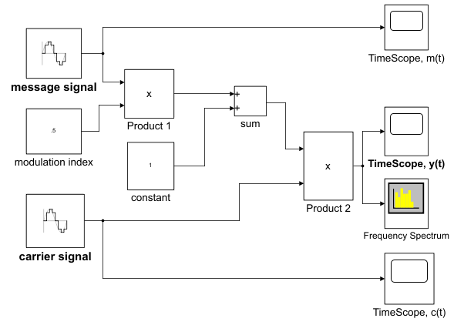

Fig. AM Simulation model

Parameters:

* Carrier Signal frequency = 2*pi*25 and sampling time=1/5000
* Message Signal frequency = 2*pi and sampling time=1/5000
* Amplitudes of both signals are 1

Sample Plot

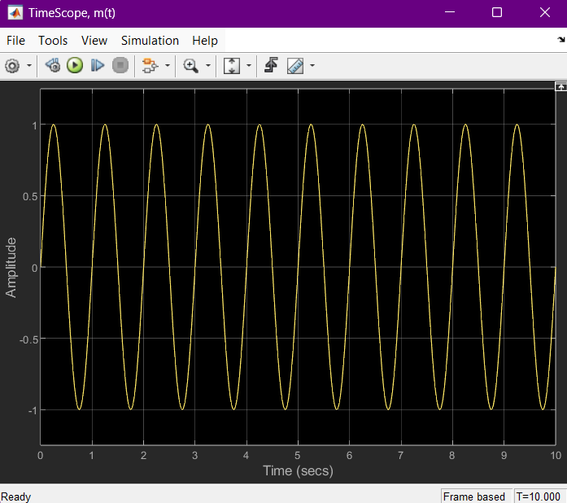

Fig. Message Signal

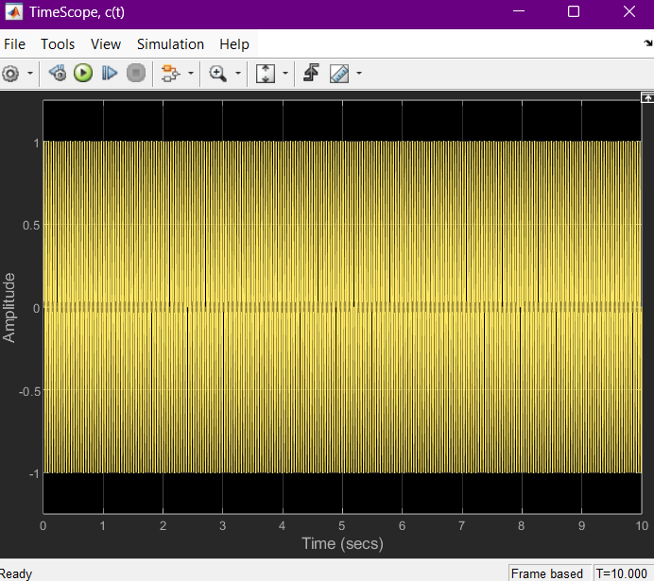

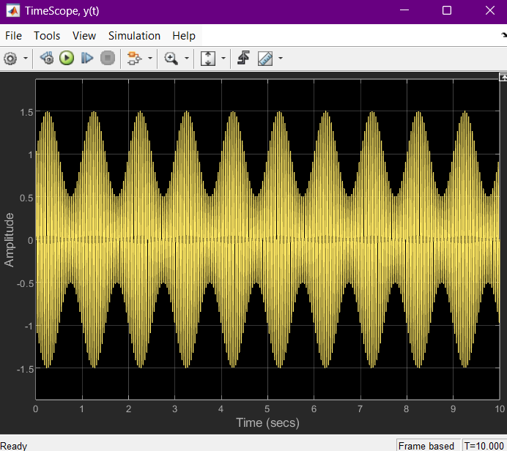

Fig. AM modulated Signal

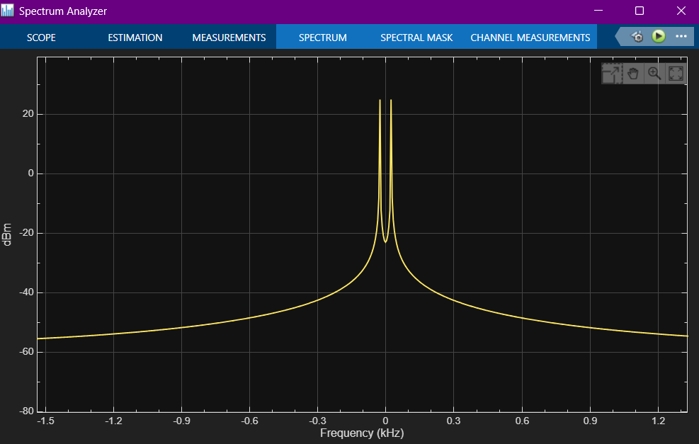

Fig. Carrier Signal Fig. Frequency Spectrum

1. Build the Simulink model of FM modulator.
2. Build Simulink Model of 16 QAM Modulator and Demodulator.

The model is given below

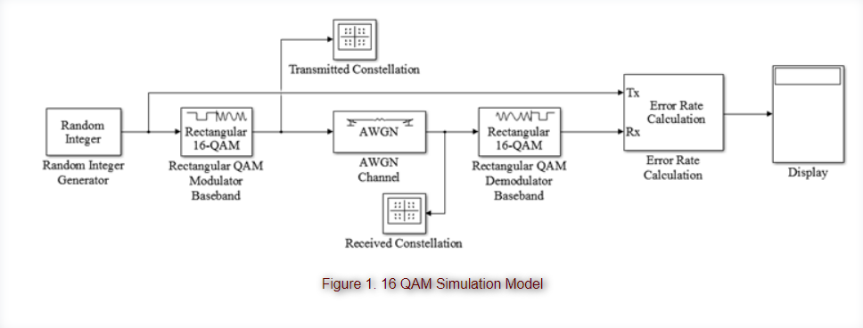

* Build the Simulink model shown in Figure
* Double-click on the Random Integer Generator and adjust the set size to a proper value (Remember that the input to the 16 QAM modulator should be from the set {0, 1, 2, …, 15}).
* In the Random Integer Generator block, set the Sample Time to 1e-6 (i.e. 1 µs) and the Samples per frame parameter to 1024.
* In the AWGN block, set the Symbol period parameter to 1e-6 (i.e. 1 µs) and the Number of bits per symbol parameter to 4 (since 16 QAM uses 4 bits per symbol).
* For the Error Rate Calculation block, set the Output data field to “port” so you can connect the Display block.
* The Display Block will show you three values. The first value is the BER, the second value is the number of incorrect bits, and the third value is the total number of bits received.
* Set the simulation time to 10 seconds.
* In both 16 QAM Modulator and Demodulator blocks, set the Constellation ordering to Gray, set the Normalization method to Peak Power, and set the value of the Peak power to 1 Watt.

1. Try to simulate a music file transmission using 16 QAM modulation with AWGN channel (model is given below).

* The music file that you will use (named Music-1.wav) is located on the Desktop.
* If the music file length is 62 second, set the Simulation Time to 62 seconds.
* In both Integer to Bit Converter and Bit to Integer Converter blocks, set the *Number of bits per integer*to 16 (this is related to the music file and not the modulation scheme).
* In both Modulator and Demodulator blocks, use Gray Constellation ordering, set the Normalization method to Peak Power, and set the Peak Power value to 1 Watt.
* In this experiment, you will adjust the value of SNR(signal to noise ratio) in the AWGN block and observe the quality of the music. Choose at least three values of SNR (high, mid, low) and **comment** on the quality of the music.

